CSS Display
The display property defines how an element participates in layout.

Common values:
block
inline
inline-block
none

Block vs Inline vs Inline-block

block
div {
display: block;
}
Behavior:
Takes full width
Starts on new line
Can set width & height
Examples:
div, p, section, header
Block elements stack vertically.

inline
span {
display: inline;
}
Behavior:
Takes only content width
Stays in same line
❌ width & height ignored
Examples:
span, a, strong
Inline elements flow like text.

inline-block (VERY IMPORTANT)
.button {
display: inline-block;
width: 120px;
}
Behavior:
Sits inline (side by side)
Allows width & height
Use case
Buttons, badges, nav items (before Flexbox)

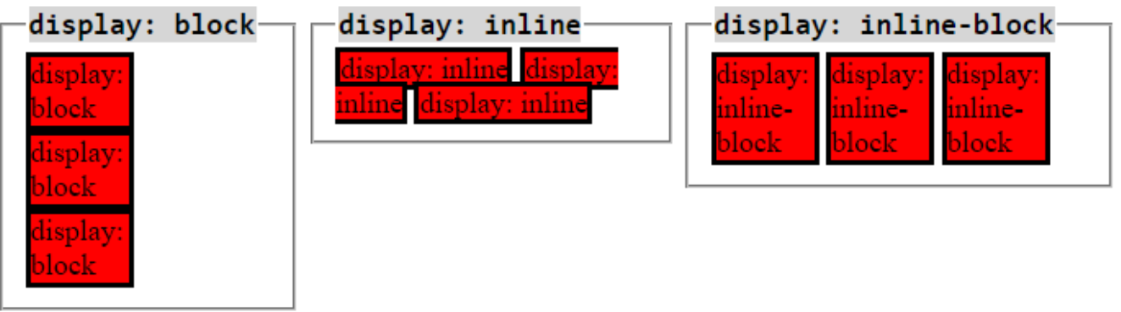

When Do Elements Stack vs Sit Side by Side?

Stack vertically when:
display: block
Normal document flow

Sit side by side when:
inline or inline-block
Floats
Flexbox (later)
“Default block elements stack, inline elements flow horizontally.”

CSS Float (LEGACY BUT MUST UNDERSTAND)
img {
float: left;
}

What float does:
Removes element from normal flow
Text wraps around it
Used historically for:
Layouts
Image + text

Problems:
Parent height collapse
Hard to maintain

Alignment

Text alignment:
text-align: center;

Inline/inline-block alignment:
Controlled by text-align on parent
Vertical alignment is hard without Flexbox (we’ll cover later).

POSITIONING

CSS Position Types

Types:
static (default)
relative
absolute
fixed
sticky

position: static
div {
position: static;
}
Normal flow
top/left do nothing
Most elements are static by default.

position: relative
.box {
position: relative;
top: 10px;
}
Behavior:
Moves relative to its original position
Still occupies space
Most important use
To act as a reference for absolute children.

position: absolute
.child {
position: absolute;
top: 0;
right: 0;
}
Behavior:
Removed from normal flow
Positioned relative to:
Nearest positioned ancestor (relative, absolute, etc.)
Otherwise → viewport
Absolute elements position themselves relative to the nearest positioned parent.

z-index (STACKING ORDER)
.box {
position: relative;
z-index: 10;
}

Key rules:
Works only on positioned elements
Higher value → on top

Stacking Context (IMPORTANT)
Created by:
positioned elements
opacity
transform
Child can’t escape parent stacking context
z-index not working → stacking context issue.

position: fixed
.nav {
position: fixed;
top: 0;
}
Behavior:
Relative to viewport
Doesn’t move on scroll
Used for:
Sticky headers
Chat widgets

position: sticky
.header {
position: sticky;
top: 0;
}
Behavior:
Acts like relative
Becomes fixed on scroll
Used for:
Table headers
Section headers
“Sticky is relative until a scroll threshold.”

Overflow
.container {
overflow: hidden;
}
Why important:
Clips absolute children
Controls scroll areas
Absolute element clipped → overflow hidden on parent.

